Integrating ICT & School Self Evaluation Planning

School self-evaluation is a collaborative, reflective process of internal school review. The ‘school self- evaluation process and the school improvement plan must be informed by assessment information, including information about literacy and numeracy, and other forms of evidence such as the views of the pupils and their engagement in learning and school life’ (DES Circular 0039/2012). As a result of the school self-evaluation process each school should produce a short school improvement plan which should contain specific and measurable targets to improve outcomes for learners. In turn the school improvement plan should act as a guide for improving teaching and learning activities in the school.

Apart from its relevant role in physically gathering and collating data so as to monitor attainment, pupil, parent or teacher feedback ICT can also be strongly integrated in the three key themes of school self-evaluation: Learner Outcomes, Learner Experiences & Teacher Practices as displayed in the teaching and learning framework below ( SSE Guidelines: 2012: 25).

In essence a vast range of ICT resources relevant to schools’ identified and targeted needs can be used purposefully to increase pupil attainment / learning outcomes in literacy and numeracy. Therefore, ICT can contribute to the pupil’s learning experiences in literacy and numeracy on a daily basis and as teachers’ practices evolve, ICT can become a central aspect of core teaching approaches.

The Teaching & Learning Framework

Within the teaching and learning framework schools can address subthemes as outlined under the three themes outlined above. Examples of self –evaluation actions include
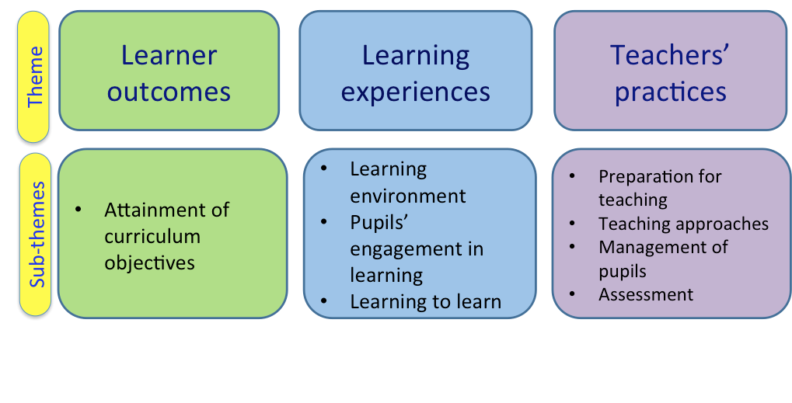

- Learner Outcomes: Attainment of Curriculum Objectives: ICT can be used to develop learning in key curriculum areas i.e. Our staff intend to develop or use of ICT in literacy / numeracy teaching and learning at all class levels through the following online programmes i.e. Mathletics, Accelerated Reader, IXL etc.

- Learning Experiences: Learning Environment: We intend to develop a school wide catalogue of curriculum relevant ICT resources / applications to be used through our ICT infrastructure e.g. IWB, iPads, Laptops in daily teaching and learning practices at all class level so that pupils are challenged and supported in their learning through ICT.

- Learning Experiences: Pupil Engagement in Learning: We intend to employ relevant ICT resources in a variety of settings 1:1, small group or whole class in order to develop and extend pupil’s active engagement in learning e.g. IWB Curriculum Resources & iPad Curriculum Apps available at http://www.clareed.ie/resourcesList.php.

- Learning Experiences: Learning to Learn: We intend to use the following ICT resources in our classrooms in order to allow pupils to capture, collate, and collaborate in sharing their learning across the curriculum – Keynote, iMovie, Evernote, Storybird etc.

- Teachers’ Practices: Assessment: To employ a range of numeracy / literacy ICT based resources in order to continuously develop, monitor and review our on-going assessment practices at all class levels e.g. Haiku, Aladdin etc.

- In the sample School Improvement Plan (SIP) below improvement targets with required actions such as those outlined above may be set, monitored and evaluated within a numeracy or literacy plan. ICT can also be purposefully used to monitor measurable outcomes over the duration of the SIP.

