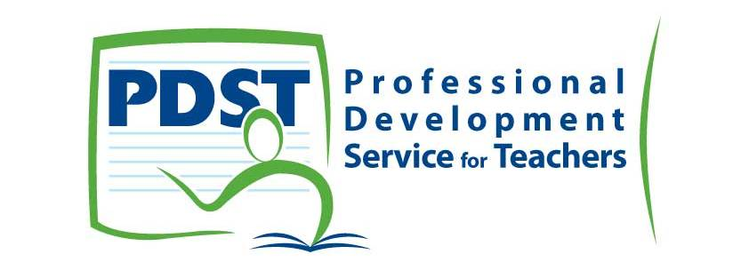
Galway EC – Online ICT Resources Workshop
27.03.14

Course Objectives

- To familiarise participants with a range of cross - curricular online teaching resources which can be used to integrate ICT in daily teaching practices.
- To make teachers aware of the potential for using ICT to enhance learner engagement in a range of active learning, classroom focused tasks where ICT is used to extend teaching and learning.

Course Overview

- We are going to engage in a range of online activities where teachers can explore ICT resources matched to a range of curricular areas. Through short online tasks and investigations we will create a online teaching resource bank which can be shared with, augmented or extended by all participants so that they can trial and evaluate the resources in their own classroom practices.

SSE Actions

- Teaching Practices: As a staff we intend to integrate the following ICT resources in daily teaching practices.
- Learner Outcomes: As a staff we intend to use the following ICT resources so as to measure and or / assess our pupils knowledge and understanding of the following areas.
- Learner Experiences: As a staff we intend to use the following ICT resources to ensure that our pupils are actively engaged in daily lessons.

- iPads Conclusion

- Sourcing Applications
- Evaluating Applications
- Using Safari and Wi-Fi
- Creating Subject Folders
- Teaching Tablet Technology Skills
- Combining Applications & Online Resources

2. Online Resource Banks

- http://www.ict.mic.ul.ie/ - All Curriculum Areas
- http://www.clareed.ie/ - 6 Curriculum Areas & Tablet Resources
- www.scoilnet.ie - Full Resource Bank
- http://school.eb.co.uk/ - Full Resource Bank

- Online Programs - 03.04.14 Preview*

- Online Programs for Literacy, Numeracy, Classroom Management etc.

 | Online Teaching Resource | Classroom Application
History | www.bbc.co.uk/schools/primaryhistory/  *Go to each of these four sites and explore the teaching resources (5 mins) | Use to teach  - Romans  - Greeks  - Vikings  - WW2
Geography | http://www.toporopa.eu/en/index.html  * Attempt a minimum of three quizzes from the homepage for EU Geography – also access the World Geography page. (5 mins)  http://www.google.com/culturalinstitute/project/world-wonders  *Visit Captain Scott’s Hut, Pompeii and The Great Barrier Reef. (5 mins) | Use to teach  - EU Physical Geography  - World Physical Geography  *Environmental Care and Awareness
Religion | http://www.bibleforchildren.org/languages/english/stories.php  *Open PDF versions of recent topics / stories you may have taught in Religion (5 mins) | Use to teach and plan  - Old & New Testament Stories
PE | http://www.ppds.ie/pcsparchive/pe/pssi/clickme.html  *Access lesson content on PE strands that you have taught or plan to teach (5 mins) | Use to teach and plan  - Athletics  - Games  - Dance  - Outdoor and Adventure
English | http://storybird.com/  * Create a story or poem to teach the writing genres and create poetry (5 mins) | Use to teach and plan  - Writing Genres
Maths | http://www.amathsdictionaryforkids.com/dictionary.html  *Search for Three – Dimensional, Acute Angle and Hemisphere (5 mins)  http://nrich.maths.org/frontpage  *Find Games, Interactives and Problem Solving activities for all class levels. (5 mins) | Use to teach and plan  - Mathematical Language
Gaeilge | https://www.youtube.com/watch?v=GxspPfVFjbg  *Access Gaeilge Resources for your classroom  http://www.cogg.ie/pdf/books/index.html  *Access reading materials for all class levels  (5 mins)

